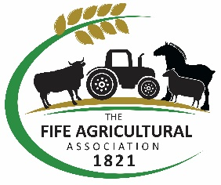
THE FIFE AGRICULTURAL ASSOCIATION

ROOT COMPETITION RESULTS 2023
The Fife Agricultural Association held its annual Root Competitions recently, with results as follows:
Fodder beet
1st J M & W Turnbull, Boghall
2nd J M & W Turnbull, Boghall
3rd J S Wilson, Balhelvie

Turnips
1st G Berwick & Son, Barbarafield
2nd Wm Craig & Son, Kinnaird

Thanks to all who entered and well done to those placed, as shown above. JM & W Turnbull will receive the Danskin Perpetual Challenge Trophy for Best Overall Root Crop with the RS Walker Silver Challenge Trophy for the Best Managed Field going to Murdo Fraser at Pitcairlie.
Well done to President James Smith and Junior Vice-President Richard Black for battling the elements to judge the crops. The Association is extremely grateful to DT Stewart & Sons of Ceres for their ongoing support of this competition.

